 | FACULTY OF FOUNDRY ENGINEERING  INTERNATIONAL WORKSHOP  90 Years of Educating Foundry Engineers by the  AGH University of Science and Technology in Krakow  connected with  XXXVI SCIENTIFIC CONFERENCE FOUNDRYMAN' DAY 2012  Krakow, 22 – 23 Nov. 2012

ENERGY CONSUMPTION IN THE FUZZY CONTROL OF FOUNDRY FURNACES

E. Ziółkowski¹, P. Śmierciak²
^{1, 2} AGH University of Science and Technology. Faculty of Foundry Engineering. Reymonta 23, 30-059 Krakow, Poland
¹ez@agh.edu.pl; ²smkpawel@gmail.com;

Keywords: automation of foundry processes, control of foundry furnaces, fuzzy controllers

Abstract
Foundry resistance furnaces are thermal devices with a relatively large time delay in their response to a change in power parameters. Developed in recent years, fuzzy control theory is increasingly being used in various branches of economy and industry. Fuzzy controllers allow to introduce new developments in control systems of foundry furnaces as well. Correctly selected fuzzy controller can significantly reduce energy consumption in a controlled thermal process of heating equipment. The article presents a energy consumption by control system of foundry resistance furnaces by fuzzy controller.

The control system with fuzzy controller for the assumed structure
Figure 1 shows an example - modelled in Simulink - of control system of resistance furnace using fuzzy controller. In this system, due to the large inertia of the object the Smith predictor has been used.
Fig. 1. Diagram of the resistance furnace control with fuzzy controller and Smith predictor

Tuning the fuzzy controller so defined is to determine the optimal values of gains on both inputs and the output [2, 3]. Optimization criterion usually takes one of the four formulas:

K=ʃu(t)d(t) | (1)
K=ʃu(t)td(t) | (2)
K=ʃu(t)²d(t) | (3)
K=ʃu(t)²td(t) | (4)

The lower K value of this criterion , the more response of the control system is compatible with the desired course in the controls. The criteria of quality control could be a measure of energy consumption of the control system, for example, resistance furnace. The regulator, for which the value of quality criterion K is higher, will be working in the system consuming more energy feeding the furnace.

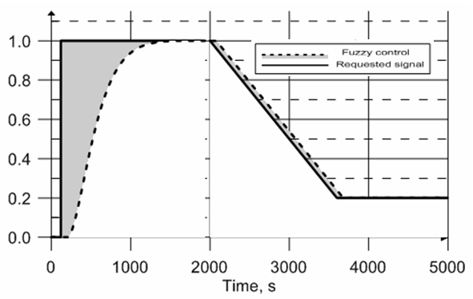
Fig. 2. The simulation results of the control response for optimal fuzzy controller parameters and the selected area differential reference signal and obtained [5]

The variety of internal structure, and sometimes very large number of parameters that define the action of these regulators make it necessary to use advanced methods of tuning of these controllers. Calculation of the fuzzy controller parameters can be achieved with the use of genetic algorithms and artificial neural networks. The optimization criterion for selection of the fuzzy controller parameters can also be proposed as the energy consumption of the control system. Optimally designed fuzzy control system, in this case the resistance foundry furnaces enables significant, reduction of energy consumption for process heat, so one can expect more organizational, economic and environmental benefits for foundries.

Acknowledgements
Calculations were performed using MATLAB / Simulink with Fuzzy Toolbox library on the computers of Wroclaw Centre for Networking and Supercomputing (www.wcss.wroc.pl), grant calculation No. 212.
The work financed by under the contract with Ministry of Science and Higher Education No. 15.11.170.448.

References
- Piegat, A. (1999). Modelowanie i sterowanie rozmyte. EXIT, Warszawa
- Byrne, J.P. (2003). GA-Optimisation of a Fuzzy Logic Controller. School of Electronic Engineering
- Mrozek B. (2006). Projektowanie regulatorów rozmytych w środowisku MATLAB-Simulink. Pomiary Automatyka Robotyka, nr 11, 5-12
- The Math Works. Fuzzy Logic Toolbox. User’s Guide
- Archives of Foundry Engineering, Issue 3/2012, 129-132

