 | FACULTY OF FOUNDRY ENGINEERING  INTERNATIONAL WORKSHOP  90 Years of Educating Foundry Engineers by the  AGH University of Science and Technology in Krakow  connected with  XXXVI SCIENTIFIC CONFERENCE FOUNDRYMEN' DAY 2012  Krakow, 22 – 23 Nov. 2012

MEASUREMENT SYSTEM OF ELECTRIC POWER DEMAND
IN A VACUUM MOULDING TEST STAND

E. Ziółkowski¹, R. Wrona¹, A. Fedoryszyn¹, K. Smyksy², M. Brzeziński²
AGH University of Science and Technology. Faculty of Foundry Engineering.
Reymonta 23, 30-059 Krakow, Poland
ez@agh.edu.pl;

Keywords: electric power measurements, vacuum moulding processes

Abstract
The proper choice of the design and operation parameters of vacuum moulding system is connected with attained level of moulding sand compaction but also with energy consumption. In such system a vacuum are generated using electric-driven vacuum pumps. The aim of the experiment is to evaluate the performance of a vacuum system basing on registered plots of selected electric power parameters of the power-supplying system of the pumps with parallel measurements of instantaneous values of pressure in selected points of model stand- 1a [1, 2]. The measurements system for power- supply unit has incorporated the recorders of instantaneous current and voltage values- 1b [3, 4]. The applied measurements system may become an effective and easy practical method of evaluating the performance of vacuum installations, used also in industry.

a) | b)
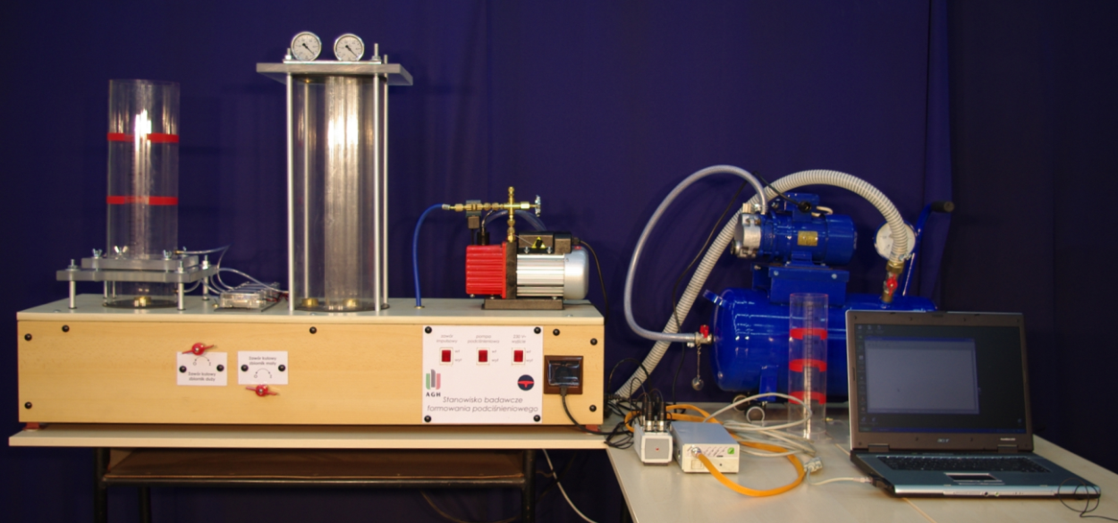 | 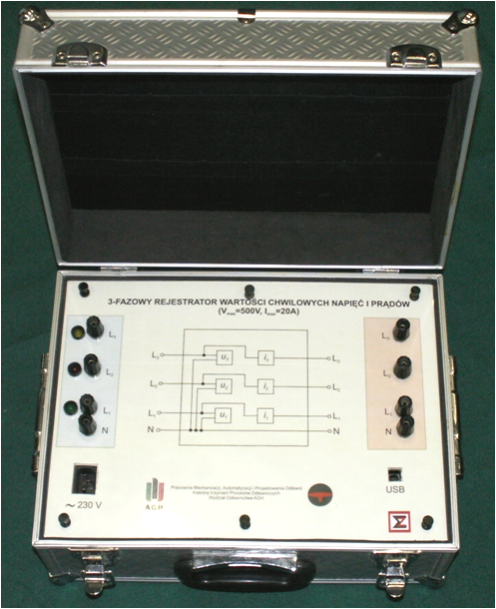
Fig. 1. Model stand for investigating of vacuum moulding- a), recorder of instantaneous voltage and current signals- general view- b)

The model test stand (presented on Fig. 1a) was constructed by analogy to solutions used in industry. It is incorporating: a vacuum installation system with pumps and tanks, moulding chamber, pressure measurement system in the vacuum installation with data recording system.
Pressure transducers are connected to the different point of vacuum installation. The recording system incorporates a microprocessor-based digital recorder.

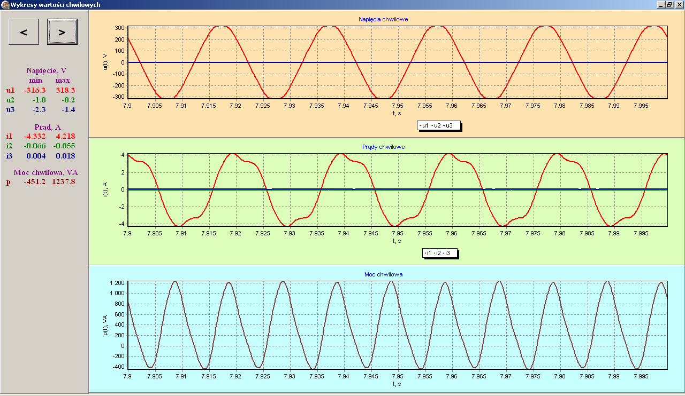 | Fig. 2. Exemplary registered plots of instantaneous voltage and current intensity levels during the steady-state operation of the two pumps

During the tests the measurements of electric power parameters are also taken – exemplary plots are shown on Fig. 2. The measurements allows to elaborate the diagrams which are connected with the process parameters and electric parameters (determining the energy consumption)- Fig. 3.
a) | b)
Fig. 3. Active power uptake by the pump No.1 and vacuum levels in the experimental installation [5] - a), relation between active power- P and absolute pressure- P_{z} in vacuum tank at the period of power growth. Vacuum pump No.1,; V₁, V₂- volumes of vacuum tanks- b)

This configuration of measurement devices allows for extending the scope of the experimental program, so the influence of basic parameters on the compaction performance considering of power demand can be investigated [1, 2].

Acknowledgements
The research was performed within the grant of MNiSW No. 11.11.170.318-6.

References
- Brzeziński, M., Wrona, R. (2011). Evaluation of automatic vacuum- assisted solution. Archives of Foundry Engineering 11(1), 113–117.
- Wrona, R., Ziółkowski E., Brzeziński M., Smyksy, K., Zyzak P. (2012). Applications of monitoring of electric power parameters to performance evaluation of a model vacuum-assisted moulding installations. Archives of Foundry Engineering 12(2), 267–272.
- Smyksy, K., Wrona, R., Ziółkowski, E. (2011). Application of a power quality analyser to the monitoring of sand preparation processes in foundry plants. Archives of Foundry Engineering 11(4), 141–144.
- Wrona, R., Ziółkowski, E., Smyksy K. (2008). Monitoring of power demand of foundry machinery, using the example of paddle mixers. Archives of Foundry Engineering 8(1), 177–182.
- Ziółkowski E., Brzeziński M., Wrona R., Smyksy K., Zyzak P. (2012). Application of Monitoring of Electric Power Parameters to Performance Evaluation of a Model Vacuum-Assisted Moulding Installation. Archives of Foundry Engineering 46/2, 267-272.

