|  |  |  |
| --- | --- | --- |
| agh_znk_wbr_rgb_150ppi | FACULTY OF FOUNDRY ENGINEERINGINTERNATIONAL WORKSHOP ***90 Years of Educating Foundry Engineers by the***  ***AGH University of Science and Technology in Krakow*** connected withXXXVI SCIENTIFIC CONFERENCE FOUNDRYMAN'S DAY 2012Krakow, 22 – 23 Nov. 2012 |  |
|  |  |  |

LINKING PHASE-FIELD METHOD WITH CALPHAD APPROACH

FOR MODELING THE SOLIDIFICATION PROCESS

M. Wróbel[[1]](#footnote-1), A. Burbelko[[2]](#footnote-2)

AGH University of Science and Technology. Faculty of Foundry Engineering.

Reymonta 23, 30-059 Krakow, Poland

[marek.wrobel@agh.edu.pl](mailto:marek.wrobel@agh.edu.pl)

**Keywords**: Phase-Field, CALPHAD, Solidification

**Abstract**

A brief review of the phase-field method in context of solidification process, together with CALPHAD approach for obtaining data needed for computations is presented. The phase-field is nowadays known and appreciated method with wide range of applications, including modelling of dendrite growth, microsegregation during that process, solute trapping upon rapid solidification, solid-state phase transformations [1-3]. The method uses a single variable ϕ, known as the order parameter (or phase-field), to represent microstructure of a system. Fig. 1 shows example of such phase-field with surface labelled as *liquid* having ϕ = 0, area noted as *solid* ϕ = 1 and interfacial region 0 < ϕ < 1.

Ginzburg-Landau Free Energy Functional [5] is used to derive dynamics of evolution of the phase-filed in time:

$F=\int_{V}{\left[f\left(ϕ, c, T\right)+\frac{ε_{C}^{2}}{2}{\left|∇c\right|}^{2}+\frac{ε_{ϕ}^{2}}{2}{\left|∇ϕ\right|}^{2}\right]dV}$, (1)

where $f\left(ϕ, c, T\right)$ is the free energy density and $ε_{c}$, $ε_{ϕ}$ being gradient energy coefficients.

To compute evolution of order parameter field (ϕ), using equations derived in number of publications (e.g. [4]), one needs to know free energy functions of calculated phases as well as values of coefficients used in equations.

The CALPHAD (CALculations of PHase Diagrams) approach is convenient way to obtain those. Example of getting such data for pure Fe will be shown in Fig. 2. The paper aims to propagate computational thermodynamics among author’s university society as there is vacancy in the field, basing on the lack of publications regarding phase-field method and CALPHAD approach.

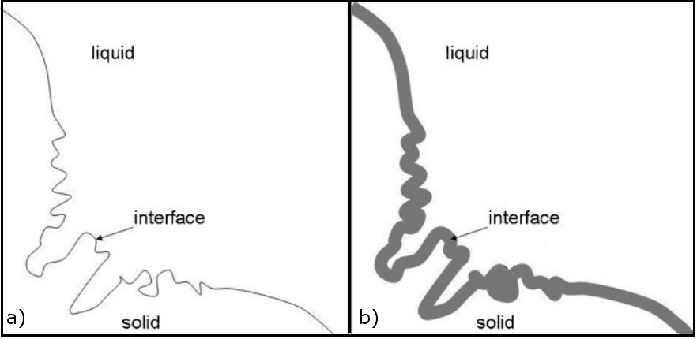

**Fig. 1**. Sharp interface (a) and diffuse interface (b) [6]

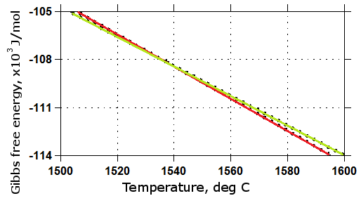

**Fig. 2**. Gibbs free energy of a phase as a function of temperature:

red line denotes liquid Fe, green – Fe-δ

**Acknowledgements**

This work was supported by fund of Polish NCN granting by the decision No. DEC-2011/01/B/ST8/01689

**References**

1. Boettinger W. J. *et al.*, *Annu. Rev. Mater. Res.,* 32 (2002), pp. 163–194
2. Steinbach I., *Modelling Simul. Mater. Sci. Eng*,.17(2009)
3. Kitashima T., *Philosophical Magazine*, 88 (2008), pp. 1615–1637
4. Provatas N, Elder K, *Phase-Field Methods in Materials Science and Engineering,* WILEY-VCH Verlag GmbH & Co. KGaA, 2010
5. Cahn J. E., Hilliard J. E, *J. Chem. Phys.*, 28 (1958), p. 258
6. Qin R. S., Bhadeshia H. K., *Mater. Sci. Tech.*, 26 (2010), pp. 803-811

1. PhD Student [↑](#footnote-ref-1)
2. Professor [↑](#footnote-ref-2)