 | FACULTY OF FOUNDRY ENGINEERING  INTERNATIONAL WORKSHOP  90 Years of Educating Foundry Engineers by the  AGH University of Science and Technology in Krakow  connected with  XXXVI SCIENTIFIC CONFERENCE FOUNDRYMAN' DAY 2012  Krakow, 22 – 23 Nov. 2012

MAGNESIUM NANOXIDE (MgO) AS A MODIFIER OF FOUNDRY BINDER - WATER GLASS

M.Starowicz¹, B.Stypuła², A.Kmita^{3*}, B.Hutera⁴, D.Drożyński⁵, A. Bobrowski⁶, M.Hajos⁷
^{1,2,3,4,5,6}AGH University of Science and Technology. Faculty of Foundry Engineering. Reymonta 23, 30-059 Krakow, Poland
³*akmita@agh.edu.pl;

Keywords: nanoxides of MgO, foundry binder- water glass, modification,

Abstract:
An attempt was made to modify the water glass with magnesium nanoxide (MgO) in methanolic solvent. The modification was made with a colloidal suspension of magnesium oxide nanoparticles obtained by electrochemical dissolution of metal. To identify the modifier, studies were carried out using TEM (Fig.1), HREM (Fig.2) and electron diffraction (Fig.3). Then, to determine the impact of modifier added to the binder on the properties of moulding sand, mechanical tests were carried out on loose sands containing modified water glass (Fig.4).
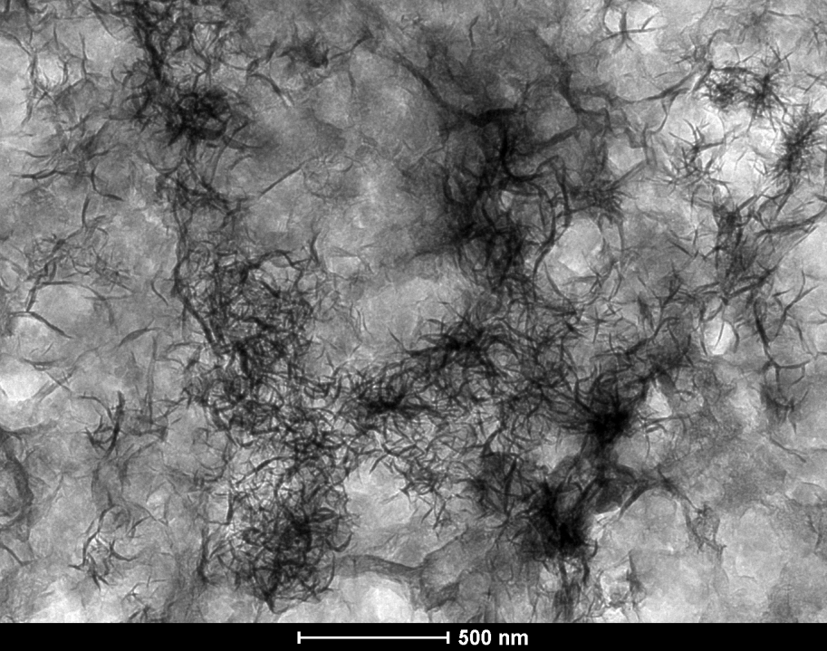 | 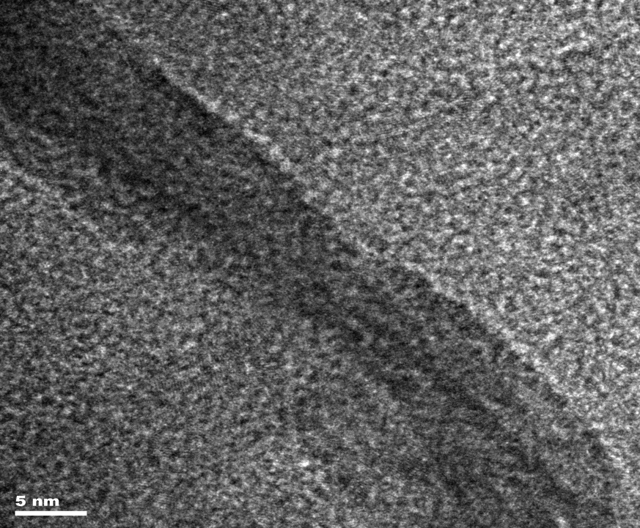
Fig.1 TEM microstructure in the light field of magnesium oxide MgO nanoparticles,  x 500 nm | Fig.2. TEM microstructure, high-resolution image with well visible structure called „pseudo-whiskers”,  x 5 nm.

Fig.3. MgO electron diffraction rings indicating the position of the maximum intensity

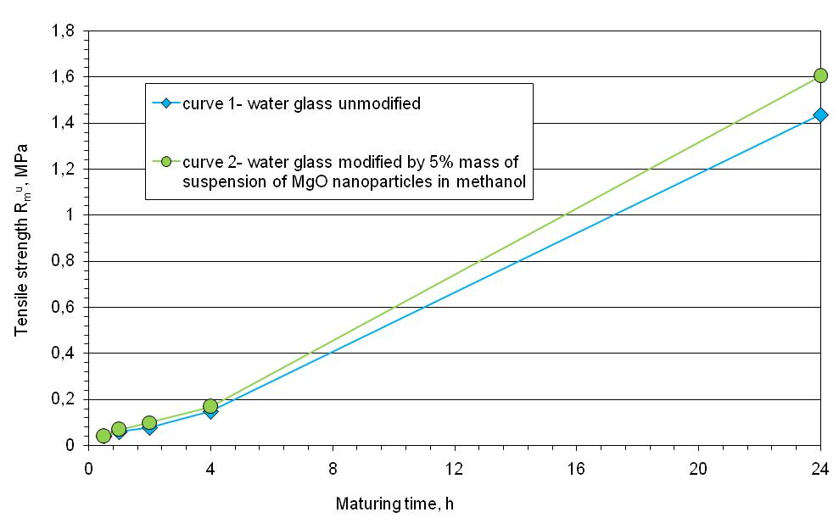
Fig.4 Strength of moulding sands with water glass, unmodified and modified. Sand composition (in parts by mass) no.1: sand – 100, water glass - 3; no.2: sand – 100, water glass – 3, suspension of MgO nanoparticles in methanol –5 mass . Hardening conditions: t_{ot} = 23.5 ºC, moisture content – 39%.

The strength of moulding sands containing binder modified with MgO nanoxide increases by approximately 20% compared with sands containing the unmodified water glass.

Acknowledgements:
The research was done within the framework of Project No. N N508 47 5538

References:
[1]B. Stypuła, J. Banaś, T. Habdank-Wojewódzki, H. Krawiec, M. Starowicz. PATENT: P-369 320 "Sposób otrzymywania mikro- i nanocząstek tlenków metali", reported: 28.07.2004, grantem: 07.10.2009.
[2] A.Kmita, B.Hutera : Effect of water glass modification on its viscosity and wettability of quartz grains. Archives of Foundry Engineering (2012 ) vol. 12 iss. 3 s. 59–62.

