|  |  |  |
| --- | --- | --- |
| agh_znk_wbr_rgb_150ppi | FACULTY OF FOUNDRY ENGINEERINGINTERNATIONAL WORKSHOP ***90 Years of Educating Foundry Engineers by the***  ***AGH University of Science and Technology in Krakow*** connected withXXXVI SCIENTIFIC CONFERENCE FOUNDRYMAN' DAY 2012Krakow, 22 – 23 Nov. 2012 |  |
|  |  |  |

***NUMERICAL SIMULATION OF STEERING SYSTEM ELEMENT CASTING***

Joanna Smyrak

Supervisors: P.Żak

M. Szucki

**Keywords:** numerical simulation, casting technology, Solid Works, MAGMA Soft ®

**Abstract**

Computer aided engineering is getting critical for the foundry industry. Nowadays, to achieve commercial success modern foundries are in need of using simulation systems.

This software supported by CAD (Computer Aided Design) system gives us knowledge about filling and solidification of a cast. Particularly, numerical approximation of temperature, pressure and velocity distribution fields are available for the engineer.

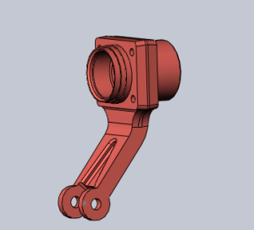

The aim of this work was to use MAGMA Soft® to simulate casting of a steering system element (Fig. 1). The casted part was made of cast iron GJL-200.

Simulation software requires digital geometry. To build a 3D model of a chosen cast, Solid Works system was used.

Fig. 1. 3D model

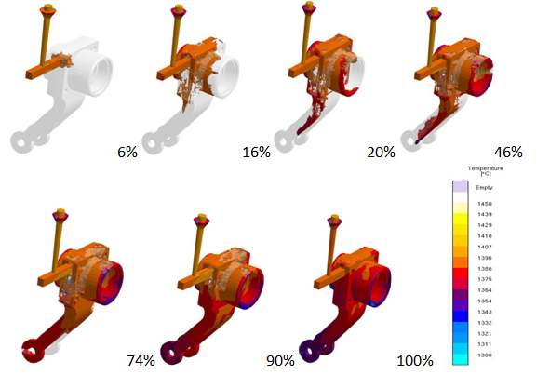

Fig. 2. Temperature distribution during mould filling

Filling and solidifying simulation results shows temperature distribution (Fig.2), pressure, liquid fraction and velocity of alloy in the mould cavity.

Results of simulation must be transformed into useful information to evaluate if a casting is sound or what must be done to improve the casting quality.

**Acknowledgements**

Authors acknowledge the Polish Ministry of Science and Higher Education for the financial support for Department of Foundry Processes Engineering, under AGH project: 11.11.170.318 task 1.