 | FACULTY OF FOUNDRY ENGINEERING  INTERNATIONAL WORKSHOP  90 Years of Educating Foundry Engineers by the  AGH University of Science and Technology in Krakow  connected with  XXXVI SCIENTIFIC CONFERENCE FOUNDRYMAN' DAY 2012  Krakow, 22 – 23 Nov. 2012

INFLUENCE OF THE MODIFICATION BY AlTi5C0.15 GRAIN-REFINER ON THE ZnAl10 ALLOY MICROSTRUCTURE

G. Piwowarski¹, P. K. Krajewski², J. Buraś³
^{1, 2, 3} AGH University of Science and Technology. Faculty of Foundry Engineering. Reymonta 23, 30-059 Krakow, Poland
¹piwgrz@agh.edu.pl; ²krajpaw@agh.edu.pl; ³jburas@agh.edu.pl

Keywords: ZnAl10, TiCAl, Modification, Microstructure, Zinc alloys

Abstract
High aluminium zinc alloys are characterised by good strength and damping properties, however in as cast state they have coarse grained structures, which significantly transfers in decreasing strength and elasticity. To this end, several treatments aimed at obtaining a fine-grained structure and improvement of such properties are applied in the technology of these alloys. The alloy Zn-10mass% Al, (ZnAl10), modified before casting to a sand mould by an addition of a traditional grain-refiner, it means: Al-3mass% Ti-0.15mass% C (AlTi3C0.15 – TiCAl), was investigated. Within investigations the thermal analyses and microscopic examinations were performed [1], [2].
The results obtained for the ZnAl10 alloy are presented in the paper. This is a high aluminium alloy representing a group of alloys: ZnAl8 and ZnAl12. The initial alloy was obtained from electrolytic Al and Zn, of the both components purity being 99.999 %. The ZnAl10 alloy, melted from these pure components, was cast in roll forms of a mass app. 0.5 kg. The material prepared in such a way was then remelted and modified before casting to the mould. Melting was performed in the graphite crucible in the resistance furnace. Samples for testing were cast as rolls of a diameter 32 mm and height of app. 80 mm. Samples were cast to dried moulds made of a classic bentonite sand moulding. The grain-refiner AlTi3C0.15, commonly called TiCAl, was applied. This inoculant is a good carrier of titanium, a strongly nucleating element. The sand mould application allowed to eliminate, to a large degree, the cooling rate influence on disintegration of casting grains, which occurs when the metallic mould is applied and renders difficult the assessment of modifier efficiency. Next, samples were cut and machined. Rolls 30 mm high and of a diameter being also 30mm (Figure 1).

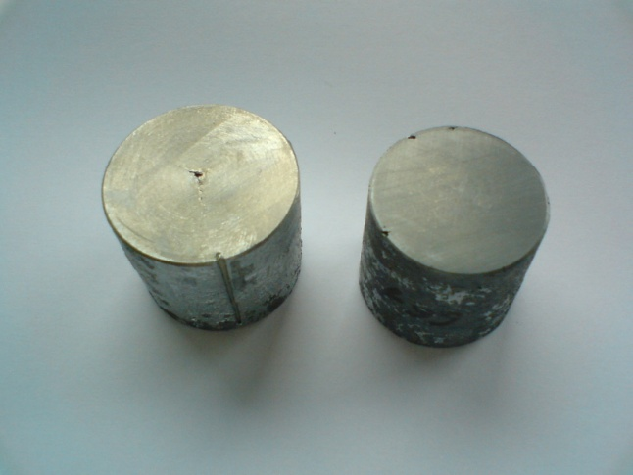
Fig. 1. Samples after end faces machining.

The sample end face was subjected to grinding and polishing and then to the electrolytic etching. Microstructure photographs were performed by the Axio Imager M2m microscope of the ZEISS Company for magnifications of 25, 50 and 100 times. Examples of the microstructure of not modified alloy are presented in Figure 2.

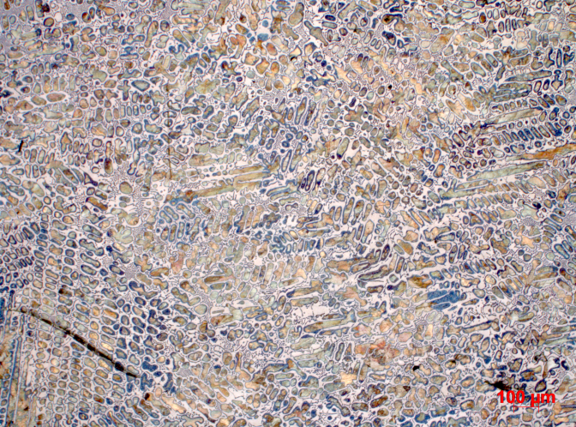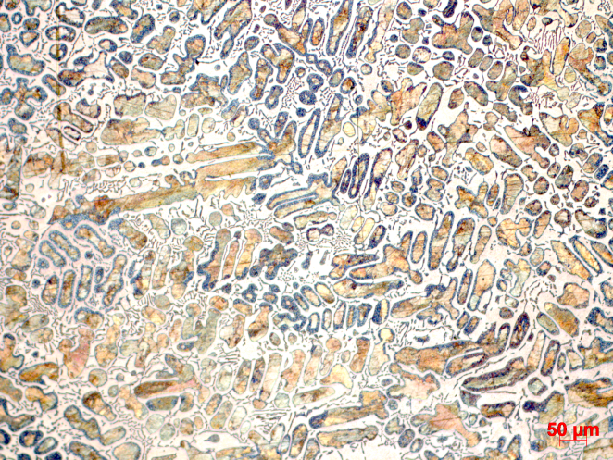
Fig. 2. Microstructure of not modified ZnAl10 alloy. Magnification 50x and 100x

Acknowledgements
The authors acknowledge The Polish National Science Center (NCN) for financial support under grant No. 2011/01/N/ST8/07054

References
- Krajewski W. K.: Research of the Heterogeneous Nucleation Mechanism in High-Aluminium Zinc Alloys Modified by Ti Addition. Monograph, AGH University, Krakow 1996, pp. 1-117 (in Polish)
- Krajewski W. K.: Shaping the structure of Zn-Al alloys by doping with Zn-Ti master alloy. Monograph, AGH University, Krakow 2001, pp. 1-67 (in Polish)

