 | FACULTY OF FOUNDRY ENGINEERING  INTERNATIONAL WORKSHOP  90 Years of Educating Foundry Engineers by the  AGH University of Science and Technology in Krakow  connected with  XXXVI SCIENTIFIC CONFERENCE FOUNDRYMAN' DAY 2012  Krakow, 22 – 23 Nov. 2012

“SIMULATION OF FILLING AND SOLIDIFICATION OF DESIGNED ALLOY FOR DECK CLEATS EXAMPLE”

J. Paśniewski,
Supervisor: M. Szucki
¹ AGH University of Science and Technology. Faculty of Foundry Engineering.
Reymonta 23, 30-059 Krakow, Poland
1) kubap89@o2.pl;
Keywords: MAGMASoft, Cast steel, Simulation, Shrinkages

Abstract
The subject of project was analysis filling, crystallization and formation of any defects
in casting mould, containing four alloys of deck cleat, used to tying mooring ropes. The main objective of the simulation was check whether feeders would be sufficient. Mould was filled by high-alloy corrosion resistant cast steel DIN 1.4408 (GX6CrNiMoNb 18-10).

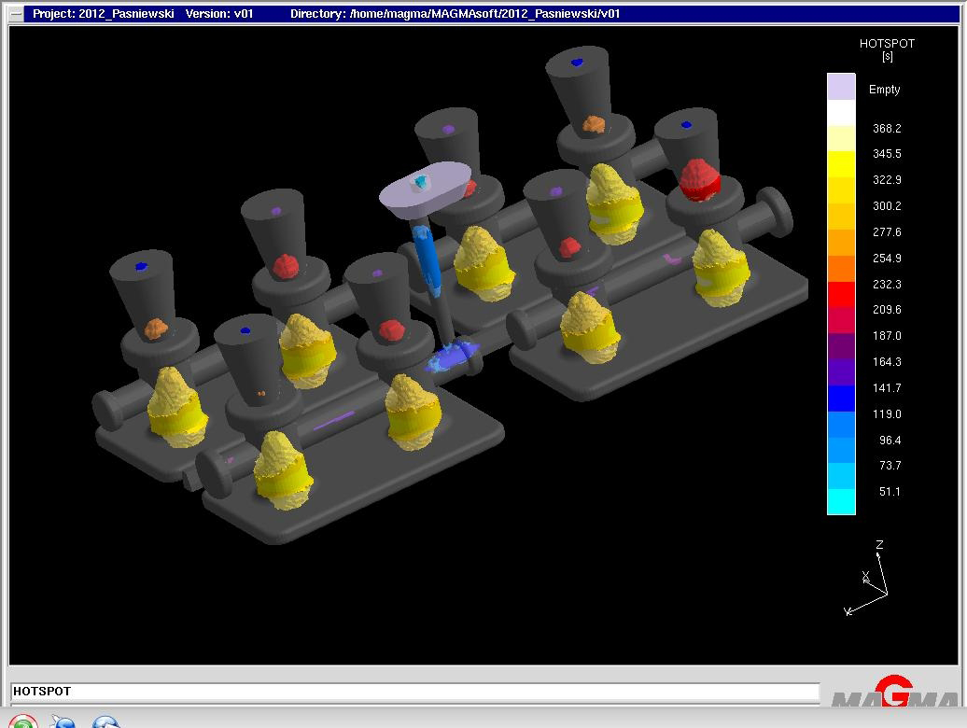

Fig. 1. Scheme of thermal nodes in form.

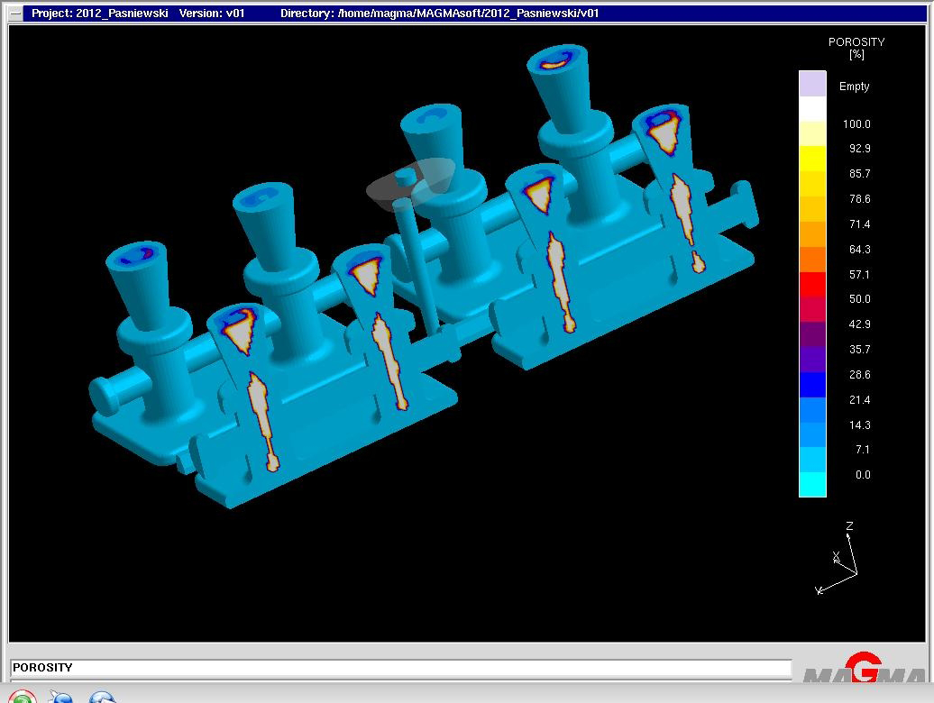

Fig. 2. Scheme of porosity and shrinkages in castings.

Simulation of high-alloy cast steel filling process was revealed that constructed mould does not meet the requirements of production of good alloy. MAGMASoft simulation process recognise the problems in construction of feeders, which result was demonstrate - with high possibility – appear of casting defects as porosity or shrinkages. Size defects pointed to coercion not only redesign the feeder, but add appropriate surplus, enabling compliance with principle of directional solidification and assurance healthy alloys.

Acknowledgements

Authors acknowledge the Polish Ministry of Science and Higher Education for the financial support for Department of Foundry Processes Engineering, under AGH project: 11.11.170.318 task 1.

