 | FACULTY OF FOUNDRY ENGINEERING  INTERNATIONAL WORKSHOP  90 Years of Educating Foundry Engineers by the  AGH University of Science and Technology in Krakow  connected with  XXXVI SCIENTIFIC CONFERENCE FOUNDRYMAN' DAY 2012  Krakow, 22 – 23 Nov. 2012

COMPOSITE ZONES OBTAINED BY IN SITU SYNTHESIS IN CASTINGS BASED ON THE NI₃AL PHASE

E. Olejnik¹, G. Sikora², E. Tyrała³, A. Kolbus⁴
^{1, 2, 3, 4} AGH University of Science and Technology. Faculty of Foundry Engineering.
Reymonta 23, 30-059 Krakow, Poland
¹eolejnik@agh.edu.pl; ²gsikora23@gmail.com; ³tyrala@agh.edu.pl; ⁴kolbus@agh.edu.pl;

Keywords: MMCs, Composite zone, In situ, Ni₃Al, TiC

Abstract
Surface improvement of mechanical properties in castings, hardness – in particular, is achieved, among others, by local hardening with ceramic particles or intermetallic phases [1,2]. One of the methods to obtain such an effect is the in situ synthesis of these phases [3]. It enables producing in certain parts of casting a composite layer or zone reinforced with e.g. carbides. The essence of this process is to have different mechanical properties in the surface area of casting and in the core.
The paper presents the results of research on the development of composite zones in castings based on the Ni₃Al phase. The primary objective of this study was to check what are the possibilities of producing TiC carbides in a composition containing substrates necessary for their formation and a nickel filler. The filler was introduced to reduce the volume fraction of carbides, having a direct influence on the mechanical properties of the composite area. The compositions were prepared with the substrate/filler mass ratio of 90 : 10 (casting M10), 75 : 25 (casting M25), 50 : 50 wt. % (casting M50). To compare the effect of changes in the mechanical and stereological properties, a reference composition containing only substrates of the TiC synthesis (casting M0) was also prepared. Each of these compositions was pressed, and the resulting compacts were placed in mould cavities. Moulds with compacts inside were then poured with an alloy ensuring the formation of an intermetallic compound, i.e. the Ni₃Al phase. The reaction of synthesis in the mould was initiated by providing the substrates with thermal energy. The heat source was the liquid alloy, whose pouring temperature was ∼1780 K. As a result of the reaction, composite zones were formed in castings. The reinforcing phase in these zones was titanium carbide, while matrix was mainly the Ni₃Al phase.
The resulting materials were examined by imaging (SEM), and analysis of the composition (EDX) and structure (XRD). To determine the surface content and the size of carbides in the composite matrix, stereological studies were conducted. Then, hardness HV of the composite zones was tested.
Figure 1 shows sample SE topographic images of composite zones produced on substrates without the filler (Fig. 1a) and with the filler added in an amount of 50 wt. % (Fig.1b).

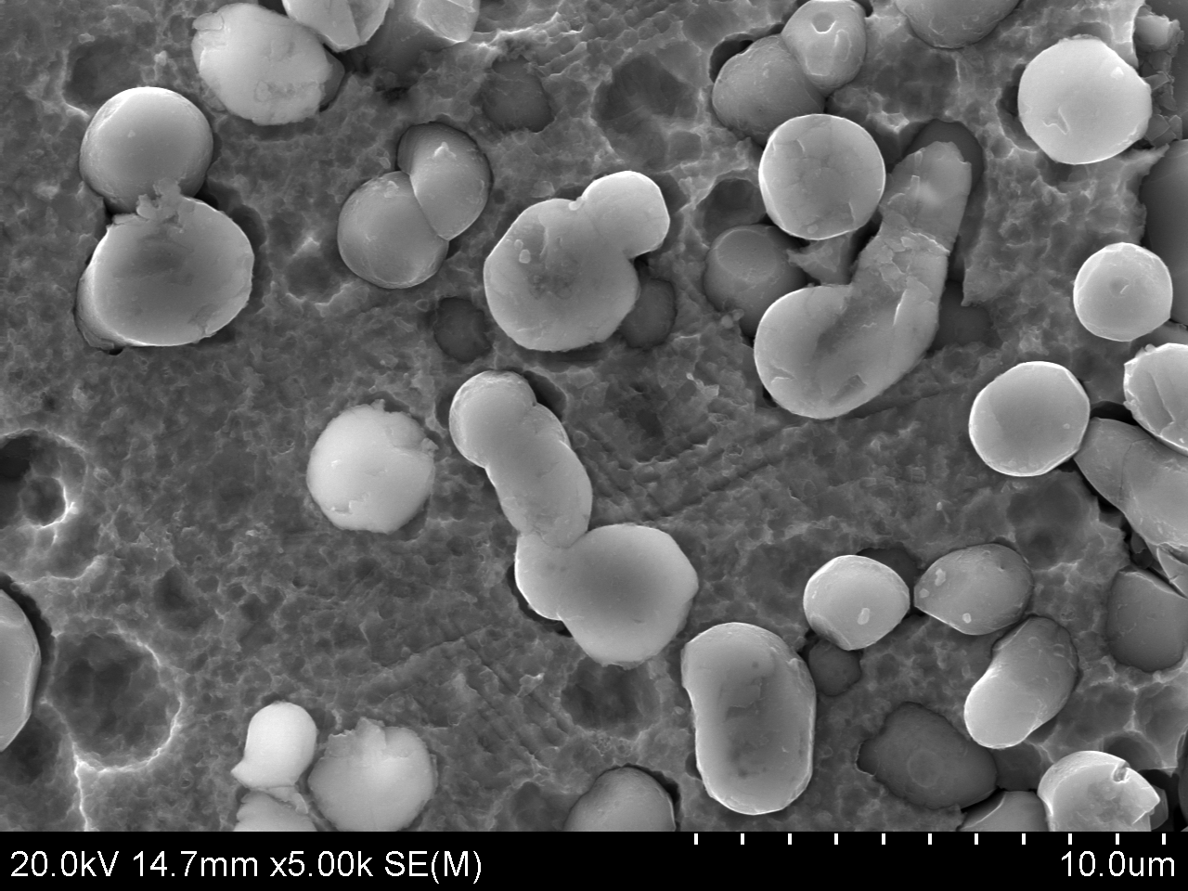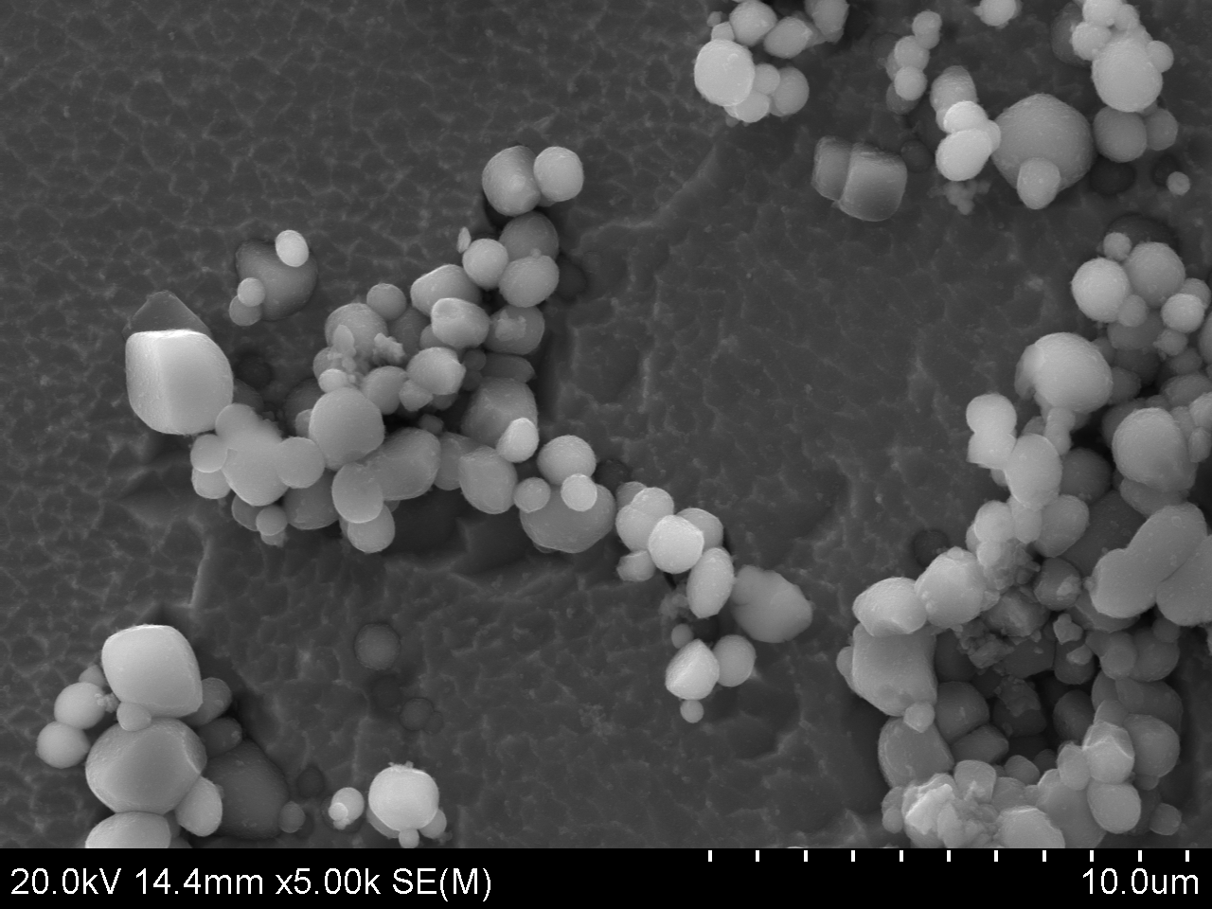
a).
b).
Fig. 1. SE topographic images of composite zones produced in castings M0 (a) and M50 (b), specimens deep-etched with aqua regia, 5000×

Figure 2 compares the results of measurements of the mean size of TiC carbides (Fig. 2a) and hardness HV30 (Fig. 2b) of composite zones produced in castings. The mean size of carbides in the composite zone decreases with the increasing content of filler (Fig. 2a). The data collected in the diagram in Figure 2b show gradual decrease of the hardness HV in composite zones with the increasing content of filler in the compact composition.
a).
b).

Fig. 2. The results of measurements of the mean size of TiC carbides (a) and hardness (b) of composite zones produced in castings based on the Ni₃Al phase

Acknowledgements

The results presented in this paper were obtained within the framework of research grant
No. N N507 311040 financed by the Polish Ministry of Science and Higher Education.

References
- Asano K., Yoneda H., Formation of in situ composite layer on magnesium alloy surface by casting process, Materials Transaction, 49 (2008) 10, 2394-2398.
- Olejnik E., Janas A., Kolbus A., Grabowska B., Composite layers fabricated by in situ technique in iron castings, Kompozyty - Composites, 2 (2011) 11, 120-124.
- Olejnik E., Janas A., Kolbus A., In situ formation on composite layer on cast steel and Ni₃Al by casting process, 69th World Foundry Congress, Hangzhou China, October 16-20, 2010, pp. 467-470.

