 | FACULTY OF FOUNDRY ENGINEERING  INTERNATIONAL WORKSHOP  90 Years of Educating Foundry Engineers by the  AGH University of Science and Technology in Krakow  connected with  XXXVI SCIENTIFIC CONFERENCE FOUNDRYMAN' DAY 2012  Krakow, 22 – 23 Nov. 2012

SEGREGATION OF ELEMENTS IN THE STAINLESS STEEL
CONTAINING 17.88% CR AND 8.75% NI

P. Malatyńska¹, J. Głownia²
^{1, 2} AGH University of Science and Technology. Faculty of Foundry Engineering.
Reymonta 23, 30-059 Cracow, Poland
¹paulina_malatynska@o2.pl; ²głownia@agh.edu.pl

Keywords: Stainless steel, segregation, profiles of element

Abstract
The effect of the elements segregation in the cast steel containing 17.88 % of chromium and 8.75 % of nickel is presented in the paper. The profiles of elements were investigated by means of the scanning electron microscopy, and the scope of the analysis comprised the line in the austenite and ferrite zone. The segregation of such elements as: Cr, Ni, Mo, Fe, C, Mn, Al, Si, P, Co and Cu was checked. The analysis was made for the 30 mm wall of the casting, reproducing the pump rotor section.

Table 1. Chemical composition of the investigated cast steel
CHEMICAL COMPOSITION
[weight %]
Cr | Ni | Mo | C | Si | Mn | P | S | Al | Co | Cu
17,88 | 8,75 | 0,81 | 0,058 | 0,35 | 1,02 | 0,036 | 0,005 | 0,032 | 0,13 | 0,36

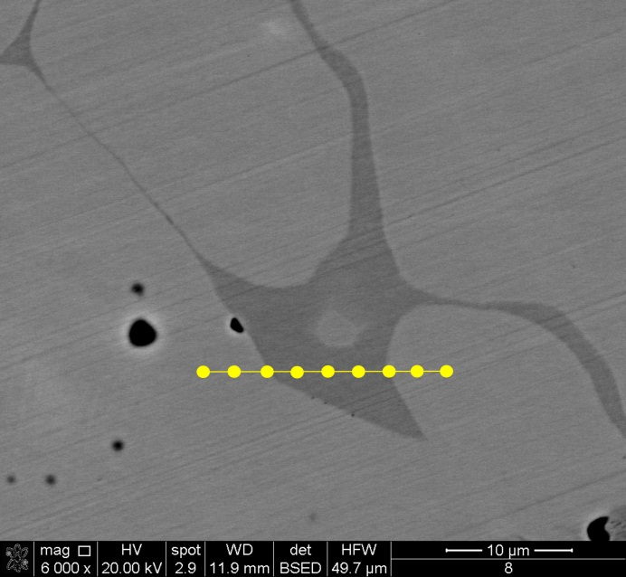
Fig. 1. Position of analysis EDS, magnification 6000x
Fig. 2. Element segregation of the investigated cast steel

Fig. 3. Element segregation of the investigated cast steel

Acknowledgements
The study was performed within the ‘Dean’s Grant’ 2012 No.15.11.170.447

References
- Malatyńska P.: Oddziaływanie różnej zawartości węgla na mikrostrukturę staliwa chromowo-niklowo-molibdenowego. Zeszyty Studenckich Prac Naukowych ”SFEROID” 13 (2012) pp. 55–60.
- Kalandyk B., Starowicz M.: Mechanical properties and corrosion behaviour of {18 Cr-11Ni-2,5Mo} cast steel. Archives of Foundry Engineering 9 (2009) pp. 87–90.
- Singh j., Purdy G.R., Weatherly G.C.: Microstructural and Microchemical Aspects of the Solid-State Decomposition of Delta Ferrite in Austenitic Stainless Steels. Metallurgical Transaction A 16A (1985) pp.1363-1369.
- Głownia J., Kalandyk B., Zapała R., Sobula S., Tęcza G., Malatyńska P., Telejko I., Brzeziński M.: Charakterystyka stali na odlewy Wydawnictwa AGH, 2010, Skrypty Uczelniane, Akademia Górniczo-Hutnicza im. Stanisława Staszica w Krakowie; ISSN 0239-6114; SU 1718
- Duh T.S., Kai J.J. , Chen F.R.: Effects of grain boundary misorientation on solute segregation in thermally sensitized and proton-irradiated 304 stainless steel. Journal of Nuclear Materials 283-287 (2000) pp.198-204.
- Kinoshita H., Watanabe S., Mochizuki S., Sakagucki N., Takahashi H.: Effect of Ni and Cr concentration on grain boundary segregation Fe-Cr-Ni alloy. Journal of Nuclear Materials 239 (1996) pp. 205-209.
- Takalo t., Sutala N., Moisio T.: Influance of ferrite content on its morphology in some Austenite Weld Metals. Metallurgical Transaction A 7A (1976) pp. 1591-1592.

