 | FACULTY OF FOUNDRY ENGINEERING  INTERNATIONAL WORKSHOP  90 Years of Educating Foundry Engineers by the  AGH University of Science and Technology in Krakow  connected with  XXXVI SCIENTIFIC CONFERENCE FOUNDRYMAN' DAY 2012  Krakow, 22 – 23 Nov. 2012

WHERE ART MEETS THE VIRTUAL TECHNOLOGY. DESIGN OF THE BALLOON SHAPE INSPIRED LAMP

Z. W. Kwak
Supervisors: E. Olejnik, P. L. Żak
AGH University of Science and Technology. Faculty of Foundry Engineering.
Reymonta 23, 30-059 Krakow, Poland
kwakzosia@gmail.com

Keywords: Idea, Decorative art, Sculpture, Virtualization, Simulation

Abstract:

I suspect that few of us are thinking about how works of art are made. What must happen that in effect reveals the act of art in the form of sculpture or decorative art?

It always starts from the idea. View on beauty of flying balloons gave the inspiration for this work also. Idea transforms in sketches of finished model conception, Fig. 1.

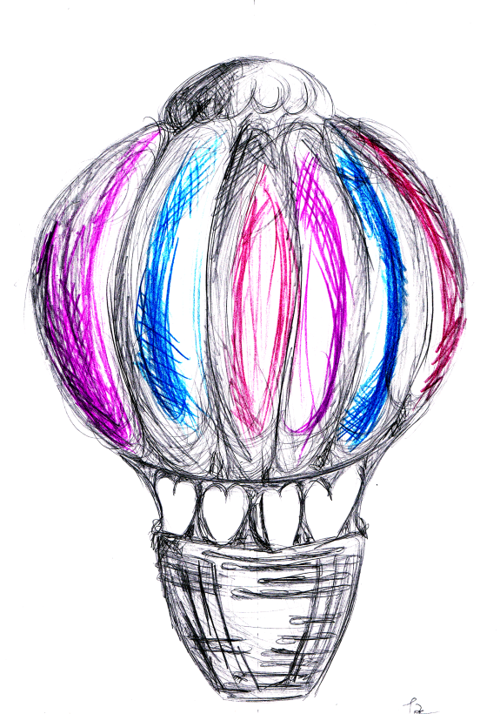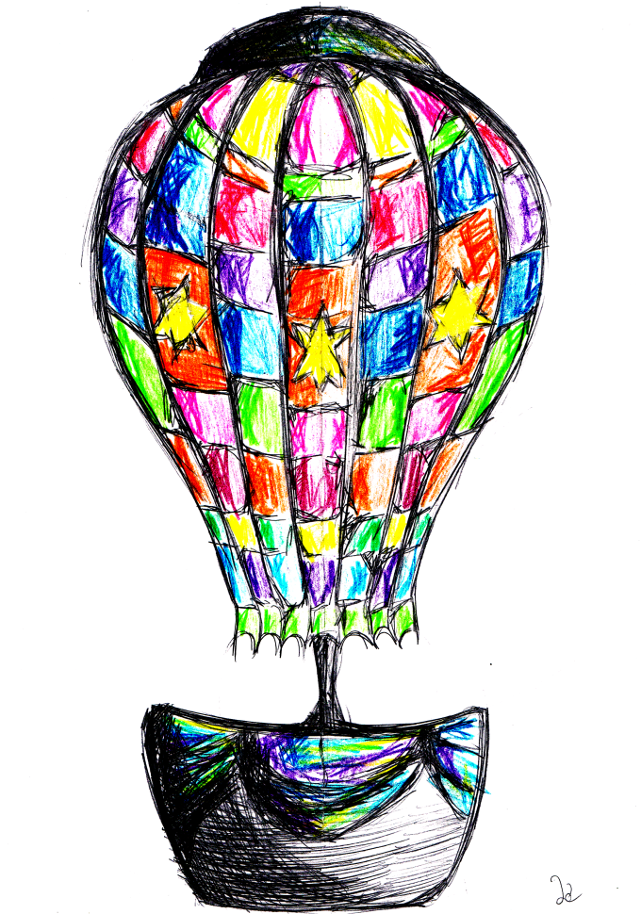

Fig. 1. Sketches of designed object

The aim of the project was to analyze possibility of making a lamp that in form is inspired by the shape of balloon. The lamp should be made using casting techniques. The examinations included: 3D model creation, calculation of the casting technology parameters, simulation of filling and solidification using MAGMASoft® and finaly analysis of the results.
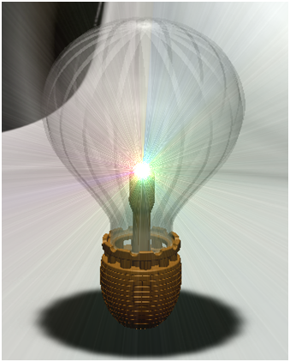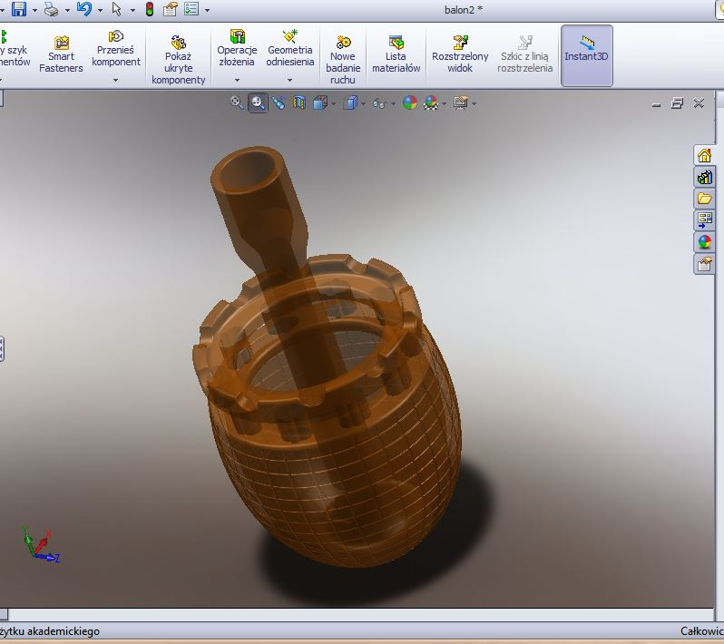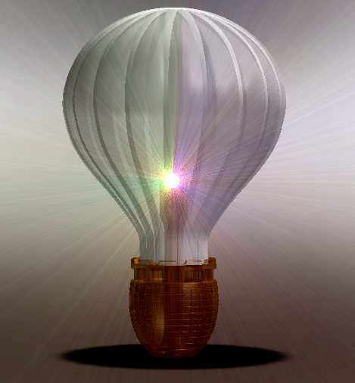

Fig. 2. 3D model of a lamp created in SolidWorks.

Cast would be made of CuSn10 (B10) alloy. Analysis of the numerical results allowed to choose proper parameters of pouring. The proposed technology is still inadequate. There are regions where the metal flow is turbulent, Fig 3.

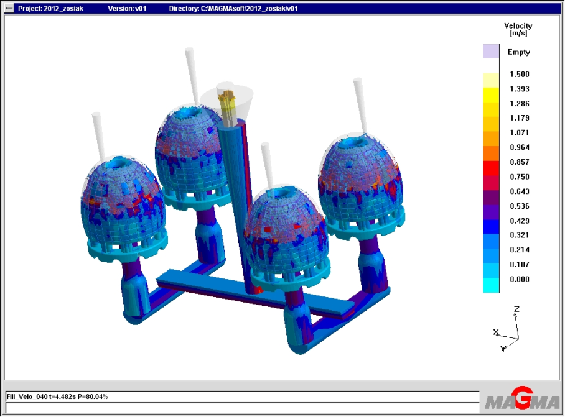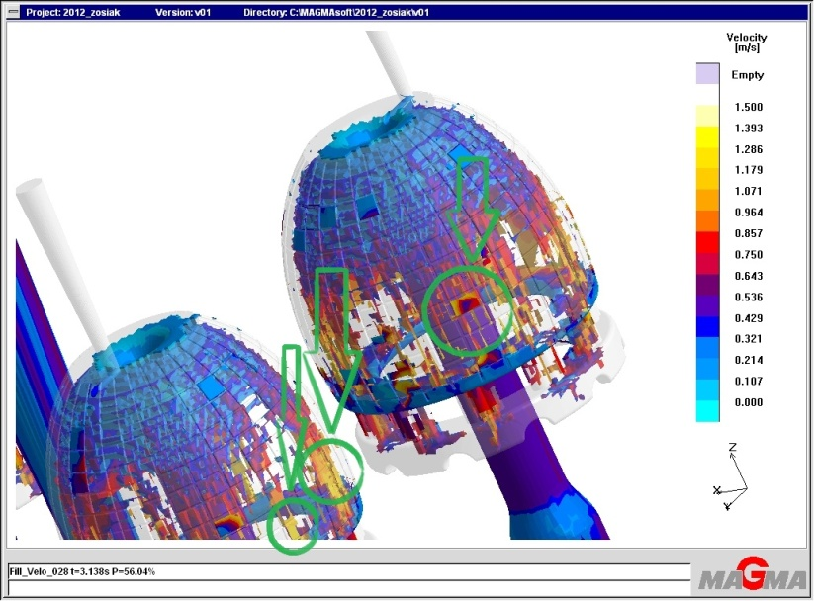

Fig. 3. Analyze of liquid velocity - pointed regions of turbulent flow.

Further analyze of casting technology according to results given by simulation systems will allow to create a casted prototype of designed model.

Acknowledgements

Author acknowledge the Polish Ministry of Science and Higher Education for the financial support for Department of Foundry Processes Engineering, under AGH project: 11.11.170.318 task 1.

