 | FACULTY OF FOUNDRY ENGINEERING  INTERNATIONAL WORKSHOP  90 Years of Educating Foundry Engineers by the  AGH University of Science and Technology in Krakow  connected with  XXXVI SCIENTIFIC CONFERENCE FOUNDRYMAN' DAY 2012  Krakow, 22 – 23 Nov. 2012

FORMULATING THE BOUNDARY CONDITIONS FOR NUMERICAL MODEL OF HEAT TRANSFER IN A SYSTEM HEAT SOURCE – HEAT SINK. THERMAL CONDUCTIVITY OF THE SYSTEM

P. K. Krajewski¹, G. Piwowarski² and J.S. Suchy³
AGH University of Science and Technology. Faculty of Foundry Engineering. Reymonta 23, 30-059 Krakow, Poland
¹krajpaw@agh.edu.pl (corresponding author); ²piwgrz@agh.edu.pl; ³jsuchy@agh.edu.pl

Keywords: Casting-mould; Thermo-physical properties; Thermal conductivity; Casting method; LFA method

Abstract
During modelling and/or numerical or analytical calculations of the solidification processes the thermo-physical properties of the examined system casting – mould – ambient are of key importance during formulating the initially – boundary conditions. The available software packages, e.g. MagmaSoft, Fluent, Flow 3D etc. have their own data-banks. These data are, in most cases, mean values of those existing in literature and their using can lead to low accuracy of the calculations. Among the thermo-physical properties the most important is coefficient of thermal conductivity. It is well known, that it strongly depends on temperature changes as well as on mass density changes. However, those relationships are, in most cases, not yet determined. There is need to perform extended examinations of the thermo-physical properties, at least for the main groups of materials which built the systems casting – mould.
The examinations should focus on changes of the thermo-physical properties together with temperature changes and mass density changes. The final aim of those examination is obtaining data which allow to predict needed values of thermo-physical properties, basing, for instance, on the mass density parameter of a sand-moulds in a Foundry, which is comparatively easy measured.
The main aims of the examinations are: Obtaining input data required for describing the initial and boundary conditions in calculated processes of heat and mass exchange as well as
elaborating algorithms which allow to predict the thermo-physical properties of the system casting – mould. The algorithms will be a basis in modelling the technological processes with exchange of heat and mass, e.g. solidification of castings.
During these examination the mould sand silica quartz – 4 wt% glass water (SQ-GW sand) was examined using two methods, i.e. the so called “Casting Method” [1] – Fig. 1 and the LFA Laser Flash Analysis method [2] – Fig. 2.
During the performed examination of the SQ-GW sand it was stated, that its coefficient of thermal conductivity strongly depends on the temperature changes, as it is seen in Fig. 3. The observed relationships justifies a need of performing more detail and expanded examination, which should also focus on the dependency thermal conductivity vs. mass density.

Fig. 1. Scheme of the Casting Method [1] | 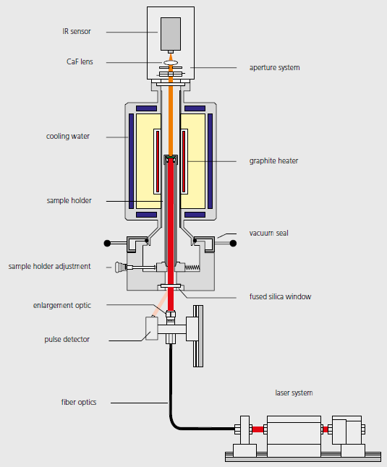  Fig. 2. Scheme of the LFA method [2]

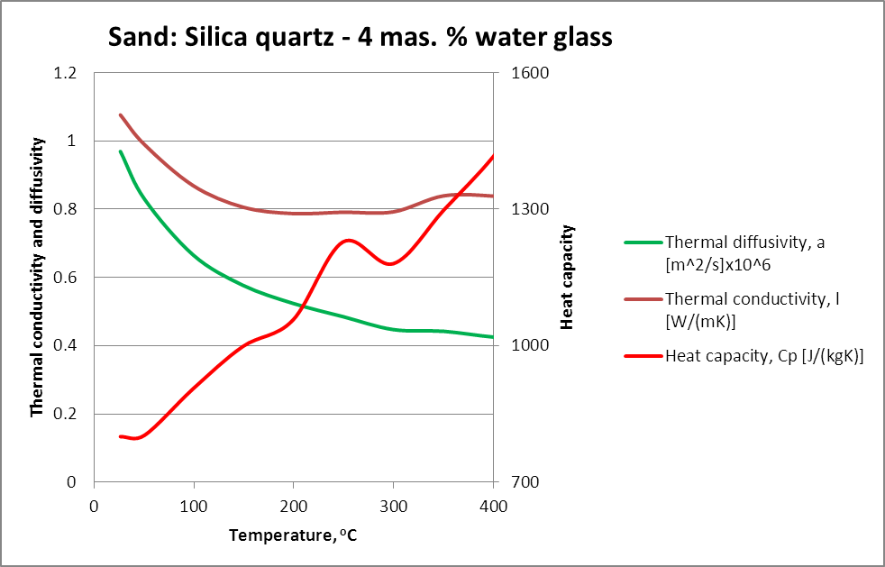

Fig. 3. Thermo-physical properties of the examined sand SQ-GW

Acknowledgements
The paper was prepared in frame of the PhD work of MSc PK Krajewski. The financial support under Dean’s Grant – AGH UST, Faculty of Foundry Engineering, entitled Determining thermal-properties vs. temperature of selected materials is kindly acknowledged. The authors acknowledge dr Adam Gradowski for technical support and scientific discussion.

References
- Krajewski W.K. and Suchy J.S., Determining Thermal Properties of Insulating Sleeves. Materials Science Forum 649 (2008) pp. 487-491
- http://www.netzsch-thermal-analysis.com; LFA 427 - product brochure

