 | FACULTY OF FOUNDRY ENGINEERING  INTERNATIONAL WORKSHOP  90 Years of Educating Foundry Engineers by the  AGH University of Science and Technology in Krakow  connected with  XXXVI SCIENTIFIC CONFERENCE FOUNDRYMAN' DAY 2012  Krakow, 22 – 23 Nov. 2012

EFFECT OF COLLOIDAL SUSPENSIONS OF MAGNESIUM OXIDE AND ZINC OXIDE NANOPARTICLES ON SELECTED PROPERTIES OF WATER GLASS.
A.Kmita^{1*}, B.Hutera², A.Bobrowski³, B.Stypuła⁴, M.Starowicz⁵
^{1,2,3,4,5} AGH University of Science and Technology. Faculty of Foundry Engineering. Reymonta 23, 30-059 Krakow, Poland
^{1*}akmita@agh.edu.pl;

Keywords: modification and structure of water glass, nanoxides of MgO and ZnO, wettability

Abstract:
The object of this study was to determine the effect of the used modifiers on the structure of water glass and quartz wettability by modified binders. The modification was performed on sodium water glass, using as modifiers the colloidal suspensions of magnesium oxide (Fig. 1a) and zinc oxide (Fig.1b) nanoparticles obtained by electrochemical, in propanol. The content of modifiers in the binder was 5 mass%. Changes in the structure of water glass were determined by measurement of FT-IR spectra of the modified binders. To determine the impact of the modifier type on the quartz wettability by modified binders (Figs. 3, 4), time-related values of the contact angle θ in a quartz-modified binder system were measured.

a)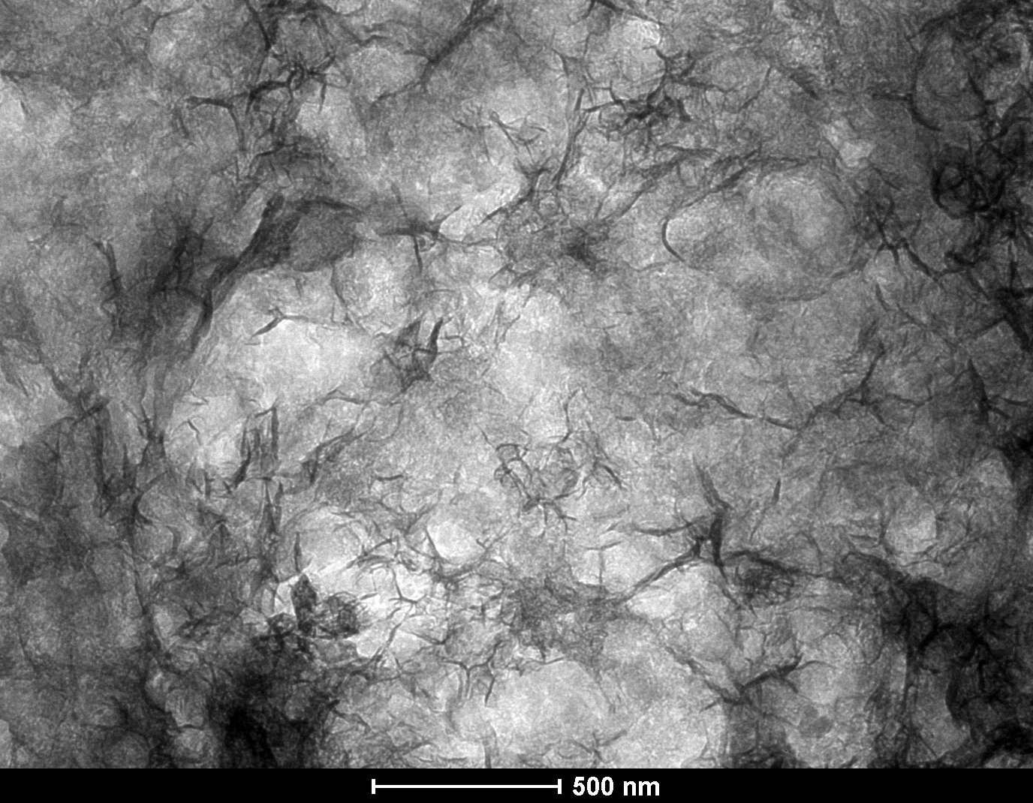 | b)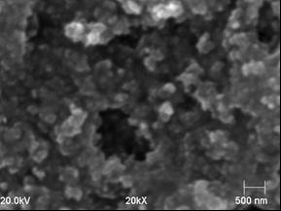
Fig.1 SEM examinations of MgO(a) and ZnO(b) nanopowders obtained in the process of an anodic digestion of metals.

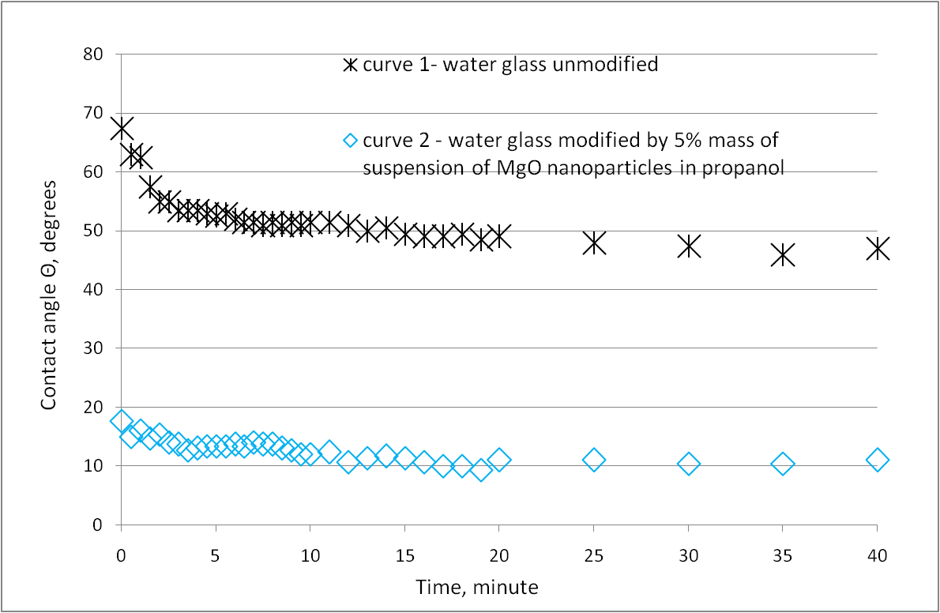
Fig.2. Changes in the contact angle of quartz wetted by water glass and water glass modified with 5 mass % addition of the colloidal MgO suspension in propanol

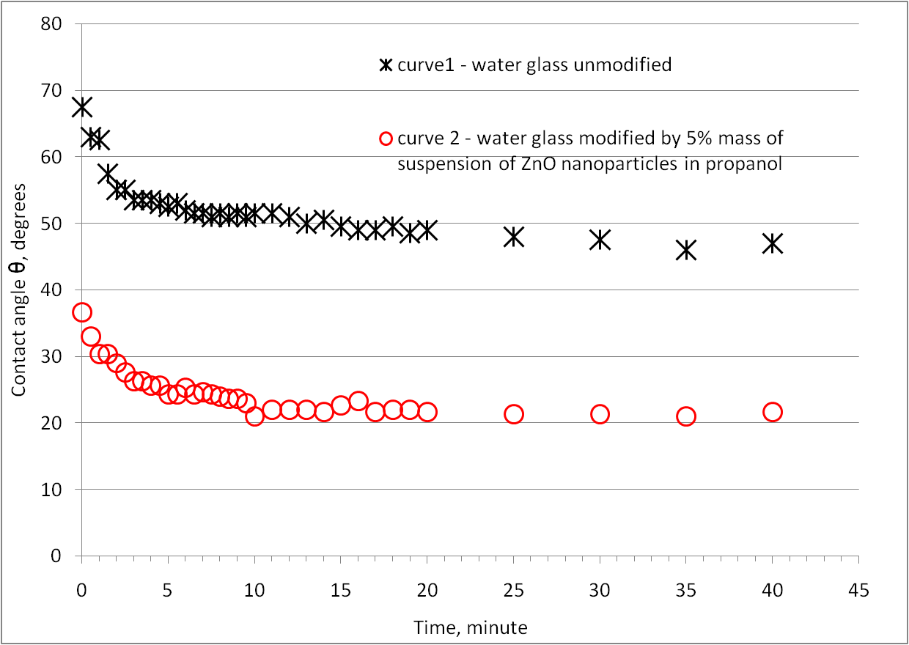
Fig.3. Changes in the contact angle of quartz wetted by water glass and water glass modified with 5 mass % addition of the colloidal ZnO suspension in propanol
Acknowledgements:

The research was done within the framework of Project No. N N508 47 5538

References
[1]B.Stypuła, J. Banaś, T. Habdank-Wojewódzki, H. Krawiec, M. Starowicz. PATENT:
P-369 320 "Sposób otrzymywania mikro- i nanocząstek tlenków metali", reported: 28.07.2004, grantem: 07.10.2009.
[2]A.Bobrowski, B.Hutera, B.Stypuła, A.Kmita, D.Drożyński, M.Starowicz: FT-IR spectroscopy of water glass - the binder moulding modified by Zno nanoparticles. Metalurgija, vol.51, No.4, pp.477-480

