 | FACULTY OF FOUNDRY ENGINEERING  INTERNATIONAL WORKSHOP  90 Years of Educating Foundry Engineers by the  AGH University of Science and Technology in Krakow  connected with  XXXVI SCIENTIFIC CONFERENCE FOUNDRYMAN' DAY 2012  Krakow, 22 – 23 Nov. 2012

THE CORROSION RESISTANCE OF STAINLESS STEELS AFTER MW PLASMA TREATMENT

D. Kasprzyk¹, B. Stypuła²
AGH University of Science and Technology. Faculty of Foundry Engineering. Reymonta 23, 30-059 Krakow, Poland
¹kasprzyk1983@gmail.pl; ²stypula@agh.edu.pl;

Keywords: plasma treatment, corrosion, stainless steels

Abstract
The austenitic stainless steels S32404 and S32615 (chemical composition Tab.1) were subject to the plasma treatment by deposition of SiC_{x}N_{y}(H) layers The treatment ware performed in the electron cyclotron resonance (ECR) micro wave plasma system - MWCVD, (2,45GHz 800W) with application of CH₄, N₂, SiH₄ and H₂ gas mixture introduced to the reactor.

The corrosion resistance of the samples was determined on the basis of LSV polarization curves in 3% sodium chloride solution at 37°C. The shape of the polarization LSV curves, Fig.1 and optical image of surfaces, Fig. 2 – 3, indicate that the deposited layers improve the corrosion resistance of both steels, particularly the pitting corrosion in the presence of chloride ions, at an elevated temperature. However, the higher resistance has been found when the SiC_{x}N_{y} (H) layer was deposited on S32615 stainless steel.

Table. 1. Chemical composition of steels
Gatunek  stali | Zawartość [% mas.]
Gatunek  stali | C | Si | Mn | P | S | Cr | Ni | Mo | N₂
S31603 | 0,02 | 0,55 | 1,60 | 0,03 | 0,03 | 16,54 | 10,1 | 2,02 | 0,064
S32615 | 0,07 | 5,5 | 1,9 | - | - | 18,5 | 21,0 | 1,2 | -

a) b)
Fig. 1. Polarization curves LSV: a) S31603, b) S32615

a)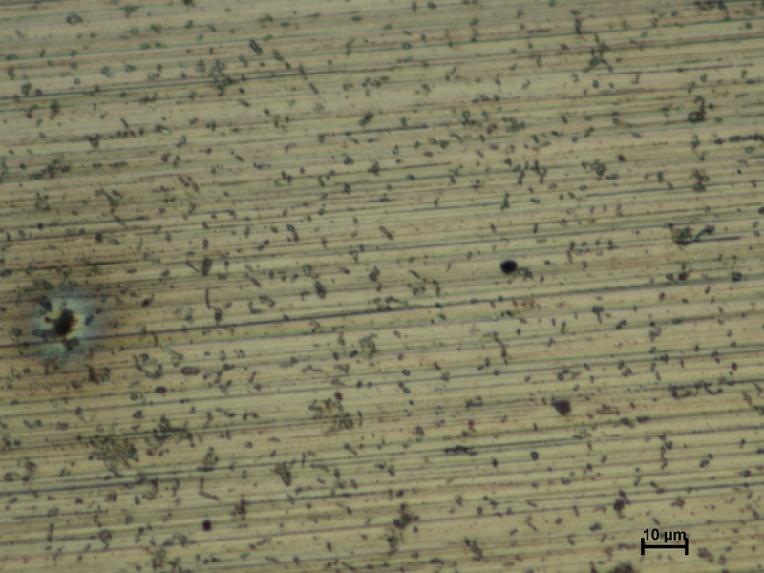 b)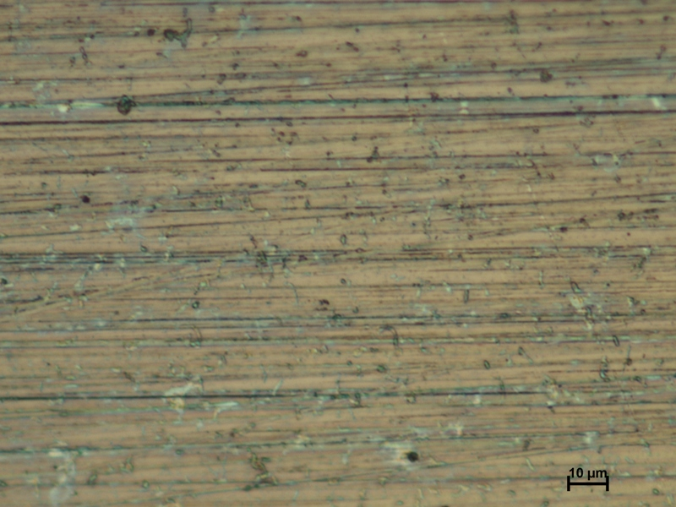
Fig. 2. Sufrace of S31603 after polarization: a) raw, b)treated

a)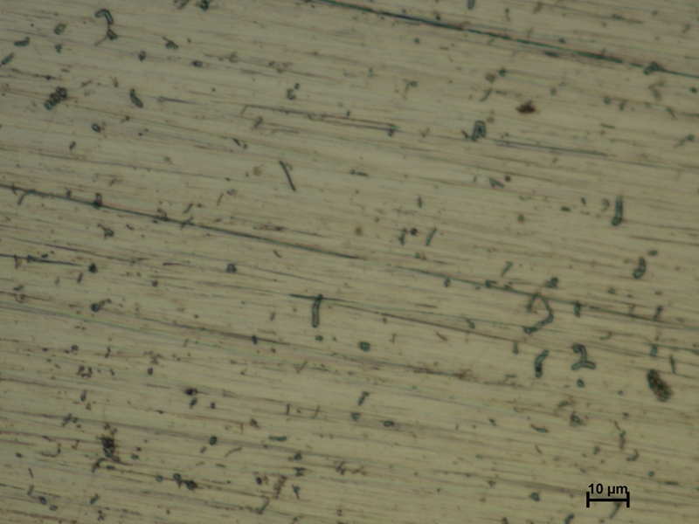 b)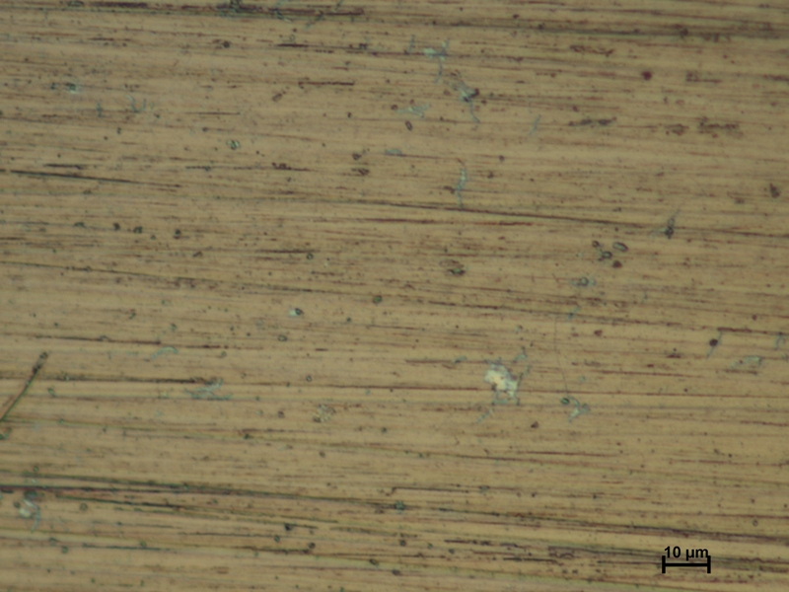
Fig. 3. Sufrace of S32615 after polarization: a) raw, b)treated

The resistance is related to the chemical composition of steels. It is significantly affected by the alloy additives, especially silicon [1].

Acknowledgements:
The research was realized with support of the Ministry of Science and Higher Education Republic of Poland (project no. 15.11.170. 453)

References
- Kasprzyk D., Stypuła B., Kuśtrowski P., Drozdek M., The role of mw plasma treatment on the corrosion resistance of stainless steels, Archives of Metallurgy and Materials- in press

