 | FACULTY OF FOUNDRY ENGINEERING  INTERNATIONAL WORKSHOP  90 Years of Educating Foundry Engineers by the  AGH University of Science and Technology in Krakow  connected with  XXXVI SCIENTIFIC CONFERENCE FOUNDRYMAN' DAY 2012  Krakow, 22 – 23 Nov. 2012

THE RECLAMATION OF SPENT SAND BONDED BY POLYMERIC BINDER BioCo2

K. Kaczmarska¹, B. Grabowska², R. Dańko³

^{1, 2, 3} AGH University of Science and Technology. Faculty of Foundry Engineering. Reymonta 23, 30-059 Krakow, Poland
¹karolina.kaczmarska@agh.edu.pl; ²beata.grabowska@agh.edu.pl; ³rd@agh.edu.pl;

Key words: polymer binders, moulding sands, used sand, spheroidal cast iron, reclamation

Abstract
At this paper the studies on reclamation of moulding sand were performed. The aim of research was to show whether can recover sand (reclaim) from the used sand bonded with a new polymeric binder and achieve suitable properties for reuse as a component of moulding sand. The study were used a polymeric binder of new generation - Bio Co2 - as a aqueous solution of two-component polymeric composition of PAA / D [1, 2]. The moulding sand contained silica sand as a sand grains and a polymeric binder BioCo2 in an amount of 3 wt % [2, 3].
Prepared moulding sand was used to perform a mould for casting ingots type Y (12.7 mm) (by ASTM A395). Obtained mould was thermally cured. The experimental melting was carried out in an induction furnace. Charge to the furnace contained Sorelmetal, technically pure silicon, Fe-Mn and steel scrap. The molten alloy, after overheated to a temperature of 1490 ° C, was held for 2 minutes at this temperature, and then spheroidizing treatment and modifications was carried out by the bell method. To the spheroidizing process were used Fe-Si-Mg (Mg 6%) master alloy and the modification was carried out using Foundrysil modifier in an amount of 0.5% by weight. The pouring temperature was about 1400 ° C.
Used sand after knocking out was initially crushed in a hammer mill and sieved; then sand was subjected to a process of relevant regeneration. Reclamation treatment were carried out by using the pilot rotor-type reclamation unit AT-2 [4, 5]. The time of reclamation was 5, 10 and 15 minutes. The rotor speed of pilot unit was 490 rot./min, 960 rot./min and 1760 rot/min. respectively.
Used sands and reclaim were subjected to analysis designed to show the degree of reclaimability. Assessment of process was based on the following indicators: the amount of dust released during reclamation, loss on ignition, reaction, the surface morphology of the sand grains.
Based on the obtained results it can be stated generally that:
- the degree of the removal of spent binding agents from sand grains is increasing with a rise of the intensity of the reclamation impact, which is compatible with the theory of working of reclamation devices and this is proper reclamation process from the view point of effectiveness;
- after 15 minutes in the process of reclamation the indicators of the degree of the removal of spent binding agents from sand grains were in range from 12.95% to 49.95% at the rotor rotational speed at 460 rot./min and 1760 rot./min respectively;
- reclamation process, which was conducted even with very intensive reclamation effects (rotator speed 1760 rot./ min), didn't cause the undesirable effect crushing sand grains, which allowed to obtain such a high degree of reclamation (Fig.1.);
- the results of sieve analysis of reclaim, which was conducted after the classification process (dust removal), didn’t show the retained weight of sand in latest 3 screens. Regenerated sand after classification had high homogeneity, main fraction in all case exceeded 90%.

a) | 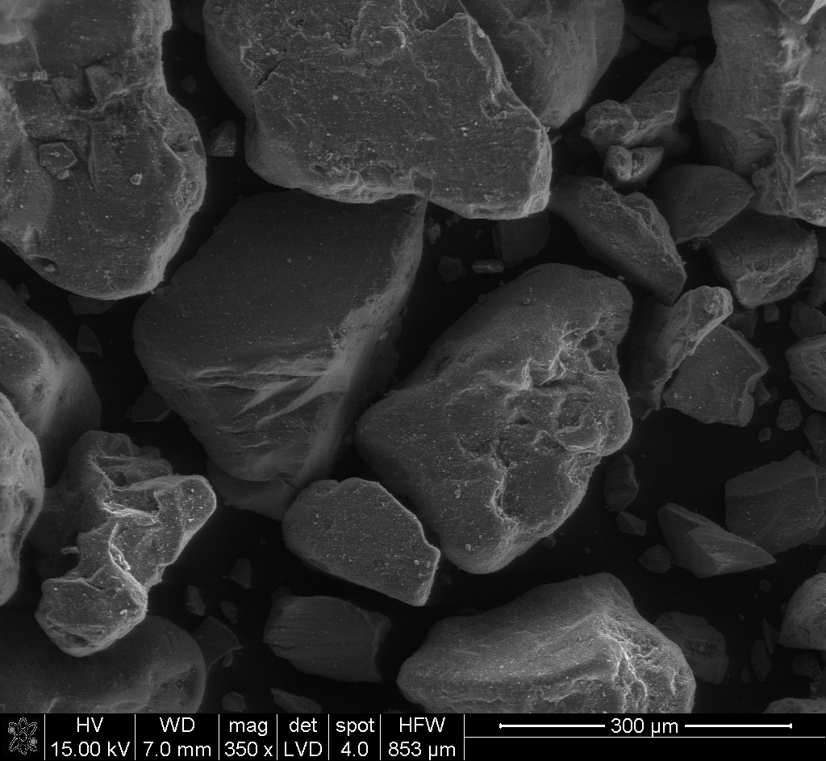 | b) | 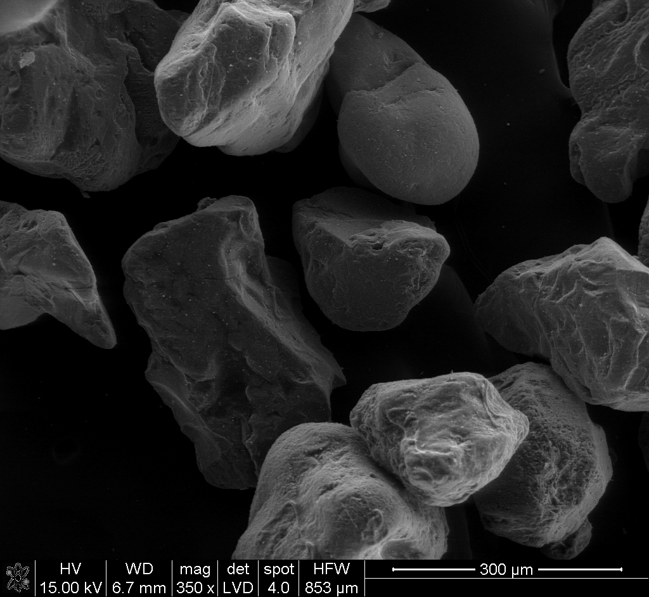
Fig. 1. Surface morphology (SEM): a) Spent sand, b) Reclaim

In summary, it can be concluded, that the moulding sand bonded by new polymeric binder BioCo2 has a good sensitivity to the regeneration and the obtained reclaim are eligible for re-use as a component of moulding sands.

The work was financially supported by the NCBiR (project nr 07.0016-10/2010).

References
[1] Grabowska B.: Preparation and characterization of biodegradable polymer binders for mould sands, Wysokojakościowe Technologie Odlewnicze, Materiały i Odlewy, Wydawnictwo PAN, Katowice-Gliwice, (2011), p. 61-72.
[2] Grabowska B., Holtzer M., Górny M., Dańko R., Grabowski G.: Microstructure and properties of test casting of cast iron made in moulding sands with the BioCo2 binder, Archives of Foundry Engineering, (2011), 11, p. 47–50.
[3] Grabowska B., Holtzer M., Dańko R., Górny M. Bobrowski A. Olejnik E.: New BioCo binders containing biopolymers for foundry industry, Metallurgy, (2013) vol. 52 no. 1 s. 47–50.
[4] Dańko R.: Experiences gathered during reclamation of used water glass and bentonite sands in extra low and ambient temperature. International Journal of Cast Metals Research, (2010) vol. 23 No. 2 p. 92–96.
[5] Dańko R.: Innovative developments in sand reclamation technologies. Metallurgy (2011) vol. 50, br. 2. 93-96.

