 | FACULTY OF FOUNDRY ENGINEERING  INTERNATIONAL WORKSHOP  90 Years of Educating Foundry Engineers by the  AGH University of Science and Technology in Krakow  connected with  XXXVI SCIENTIFIC CONFERENCE FOUNDRYMAN' DAY 2012  Krakow, 22 – 23 Nov. 2012

MODELLING OF HETEROGENEOUS NUCLEATION IN AlZn7 ALLOY. RECONSTRUCTION OF SIZE DISTRIBUTION OF NUCLEANT PARTICLES

B. Gracz
AGH University of Science and Technology. Faculty of Foundry Engineering.
Department of Foundry Processes Engineering.
Reymonta 23, 30-059 Krakow, Poland
gracz@agh.edu.pl

Keywords: Crystallization, Nucleation, Nucleant Particles, Size Distribution, Inverse Modelling

Abstract
The formation of any phase is usually a non-equilibrium process that follows a series of steps until a thermodynamically stable state is achieved [1]. The condition of supersaturation or supercooling alone may not be sufficient cause for a system (liquid) to nucleate. Before crystals can develop there must exist a number of tiny nucleant particles in the melt that act as centres of nucleation [2].
The reconstruction algorithm for nuclei size distribution for heterogeneous nucleation bases on, among other, the experimental input parameters such as undercooling and grain density. In this paper authors describe the procedure of obtaining input data for aforementioned algorithm for binary alloy - AlZn7 - that follows a series of steps. In order to eliminate the influence of the ambient, to ensure strict control of process conditions, and thus to ensure repeatability of results, the Universal Metallurgical Simulator and Analyzer (UMSA) was used [4-5]. The procedure steps [Fig. 1.] are as follows:
- Melting AlZn7 alloy using pure components,
- Casting strength standard samples,
- Machining the UMSA samples from the strength standard samples,
- The experiment in the UMSA – AlZn7 solidification under controlled cooling rate,
- Analysis of cooling curves,
- Differential scanning calorimetry (DSC) examine is performed in order to identify the equilibrium temperature,
- Calculation of undercooling (1st critical data),
- Preparing samples for metallographic examinations,
- Metallographic analysis in polarized light,
- The primary phase grains sizes measurements using the Axio Imager 2M.2 Image Analyzer Software,
- Determining primary phase grain density (2nd critical data).

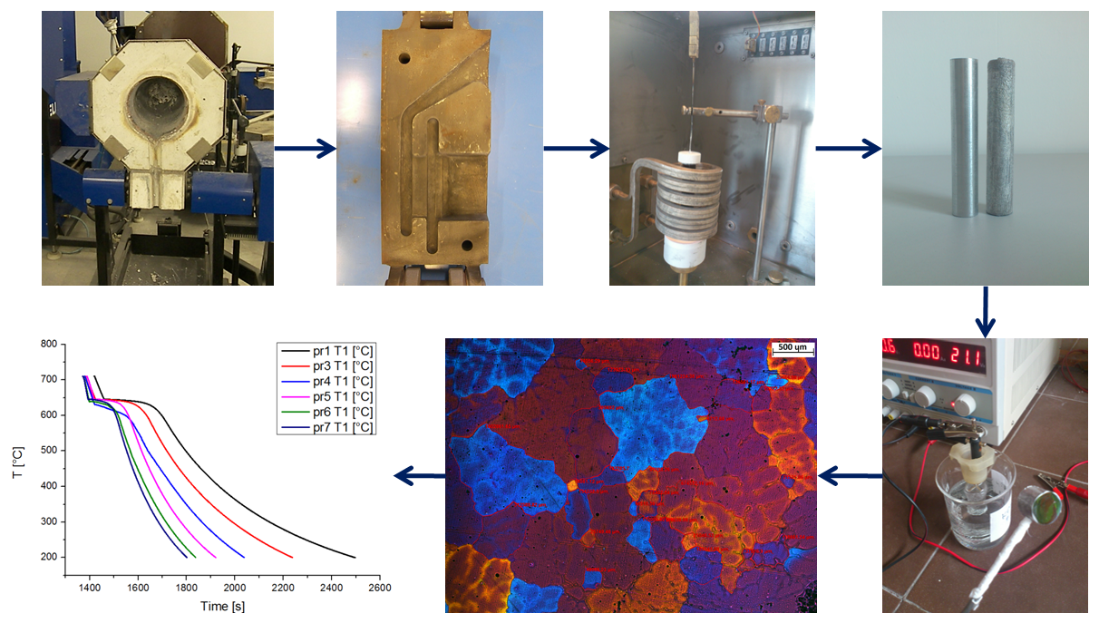
Fig. 1. Diagram above show main steps of the proposed procedure

Getting to know the nuclei size distribution leads to better understanding crystallization process. The number and size of a nucleant particles determine the probability of a nucleation event and thus determine mean grain size and mechanical properties of a casting [3].

Acknowledgements
The authors acknowledge financial support from the Polish Ministry of Science and Higher Education under Dean’s Grant AGH No. 15.11.170.446. A special thanks go to
Professor W. K. Krajewski, PhD P. L. Żak, MSc B. Augustyn and MSc. D. Kapinos for useful discussions and assistance during this paper preparation.

References
- Brantley S. L., Kubicki J. D., White A. F. (Eds.), Kinetics of Water-Rock Interaction. Springer Science+Business Media, LLC, 2008 (Chapter 7 – Nucleation, Growth, and Aggregation of Mineral Phases: Mechanisms and Kinetic Controls, pp. 259-333)
- Mullin J. W., Crystallization, 4th Ed., Butterworth-Heinemann Ltd, 2001
- Cantor B., O’Reilly K. (Eds.), Solidification and casting, IOP Institute of Physics Publishing Ltd, Bristol and Philadelphia 2003
- Universal Metallurgical Simulator and Analyzer (UMSA5/MTC_MG) – user manual, December 2010
- Method and Apparatus for Universal Metallurgical Simulation and Analysis, United States Patent No. US 7,354,491 B2, Apr. 8, 2008

